User stories: are short descriptions of a feature from the perspective of a user, and acceptance criteria are the conditions that must be met for the feature to be done.

As a <type of user> i want <goal> so that <reason>

Examples of user stories with acceptance criteria are:

As a user, I want to log in to the website using my email and password.

Acceptance criteria:

The login page should allow users to enter their email addresses and passwords.

As a user, I want to search for products using keywords. Acceptance criteria:

The search function should return relevant results based on the user’s query.

As a user, I want to check out my shopping cart and pay for my order. Acceptance criteria:

The checkout process should enable users to enter their payment information and complete the transaction without errors.

As a user, I want to view my credit card statement online. Acceptance criteria:

The product should load within 3 seconds on a 4G network. Display statement balance, total balance, minimum payment due,

payment due date, and error message if service not responding or timeout.

Acceptence ceritier:

“Conditions that a software product must satisfy to be accepted by a user, customer or other stakeholder.

Invest:

-------------------------------------------

A User Story is a tool used in Agile software development to capture a description of a software feature from an end-user perspective.

A correctly written User Story should adhere to the INVEST criteria,

which stands for Independent, Negotiable, Valuable,

Estimable, Small, and Testable.

Here is an example template of a User Story:

As a… <”CUSTOMER” or “USER” who directly benefits

from the successful delivery of this User Story>

I want to… <perform a “FEATURE” specified in the User Story>

So that…

<”BENEFIT” / “VALUE” that the customer or user will enjoy on the successful delivery of this User Story>

1. Here is an example of User Story: As a customer, I want to search for products by category so that

I can find the products I am looking for more easily.

What are 3c's for a good user stories?

* a “Card” (or often a Post-It note), a physical token giving tangible and durable form to what would otherwise only be an abstraction:

The standard format used for writing the user story on the card is as follows:

As a [user type], I want / need [goal] so that I can accomplish [justification/business value].

* a “conversation” taking place at a different time and places during a project between the various people concerned by

a given feature of a software product: customers, users, developers, testers; this conversation is largely verbal but most often supplemented by documentation;

* the “confirmation”, finally, the more formal the better, that the objectives the conversation revolved around have been reached.

A user story template defines the format that is used while writing user stories. According to Agile Alliance the most common template uses the format, “As a… I want to… So that…”

As a (who wants to accomplish something)

I want to (what they want to accomplish)

So that (why they want to accomplish that thing)

**User Story Template: The Role, the Action, and the Benefit**

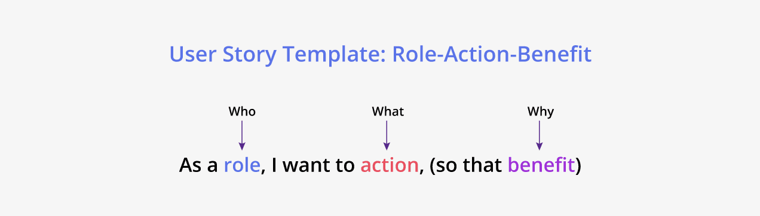

Unleash your potential with Agile Management! Obtain [**agile certificate online**](https://www.knowledgehut.com/agile-management) and guide your team towards success with adaptable and effective strategies.

A user story template defines the format that is used while writing user stories. According to Agile Alliance the most common template uses the format, “As a… I want to… So that…”

* As a (who wants to accomplish something)
* I want to (what they want to accomplish)
* So that (why they want to accomplish that thing)

A user story is written from the point of view of the user. It describes the role of the user, the action or what the user needs and the why of the story or the benefit that it provides.

**Let’s look at each of these components in detail:**

* **The role:**The role refers to the user who uses the system or for who the feature is being built. The developers are not the users of the feature.
* **The action:**The ‘what’ part of the story suggests the action or the behavior of the system. Each story has a unique action.
* **The benefit:** This is the result of the action, which is what the user needs to happen.

**Examples:**

As <a user> I want to be able to <search> so that <I can get the products I want>

As <a user> I want to able to <add items to cart> so that <I can check out the items>

## How to Write a Good User Story with INVEST

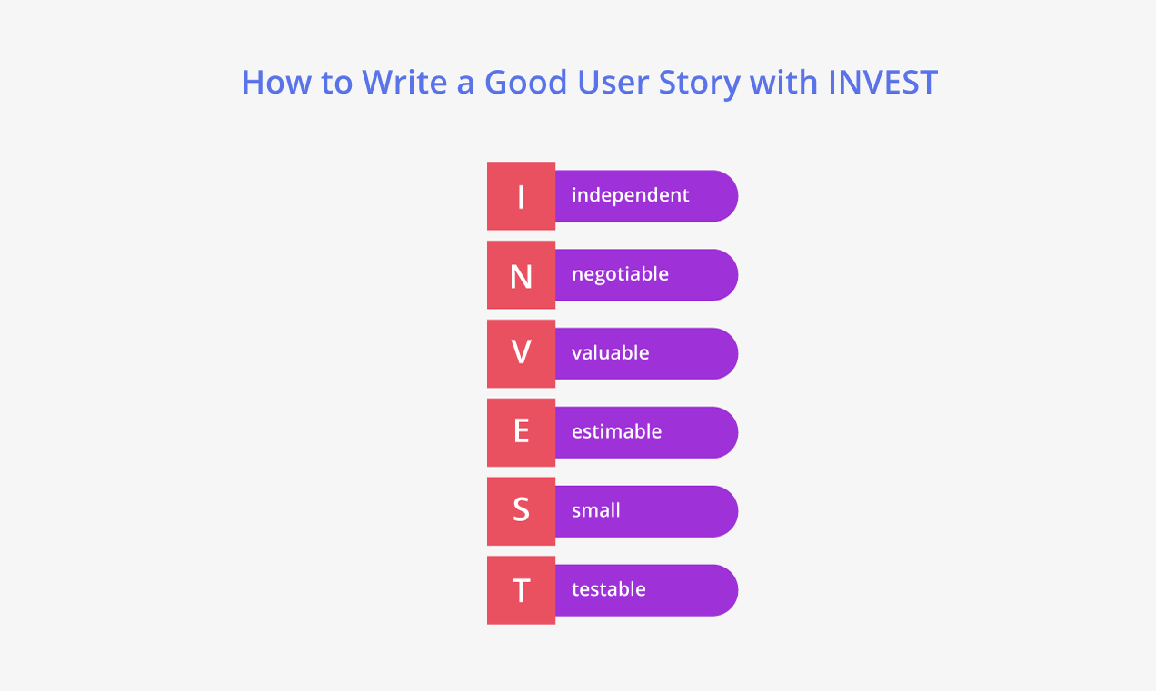

INVEST is an acronym for:

* Independent
* Negotiable
* Valuable
* Estimable
* Small
* Testable

A good user story should encompass all these properties. Let’s examine each of these features:

* **Independent:** Keeping stories independent of each other helps to prioritize stories on the backlog. If a story is dependent on other stories, then it cannot be taken up till the other stories are completed, even it has a higher priority.
* **Negotiable:** A story is negotiable which means that it can be altered based on the conversation that happens between the developers, Product Owners and consumers. A collaborative dialogue between the developers and the users for whom the feature is being developed, or the user’s proxy, that is the Product Owner, is a must. All parties must arrive at a common vision and then development must start.
* **Valuable:** The user story must be measurable, which means that it must add value to the overall project. So, a user story must add value not just to the user for who it is being developed but it should also satisfy non-functional requirements.
* **Estimable:** A user story must be estimable so that its value and subsequent priority can be gauged. This helps the product owner decide its priority in the product backlog.
* **Small:** User stories represent the smallest unit of work in Scrum projects and represent a small functionality that the product delivers. If the user stories are large, they must be broken down into smaller units as smaller user units help in faster delivery of the features.
* **Testable:** Every user story needs to be testable to confirm that it is working as it should and delivering value to the customer. The acceptance criteria are written for this purpose. When the user story passes the acceptance criteria it is complete and ready to be shipped.

reference links:<https://www.parabol.co/blog/user-story-examples/#:~:text=and%20dashboard%20management.-,User%20story%20examples%20for%20login,regain%20access%20to%20my%20account>

45 User Story Examples To Inspire Your Agile Team

Feed your imagination with 45+ user story examples that will transform your approach to product development and inspire your own user stories

<https://ascendle.com/ideas/writing-user-stories-its-not-as-difficult-as-you-think/>

PRD + Solution Design/HLD/LLD + Each module --> User stories + Agile - Scrum methodology

 Common modules :

Enterprise Apps  
STLC + SDLC  
User stories  
Agile Project Management - Scrum

Track specific:

QA : Test PLan + Test Strategy + Test cases + Test data

Java : Java concepts + SpringBoot + Microservices Architecture + DB connections

UI/UX : AngularJS/ReactJS + HTML5

Design Pattern in MSA :

a. SRP : Single Responsbility Pattern  
b. CCP : Common Closure Pattern  
c. Decomposition by business capability  
d. Decomposition by Subdomain  
e. API Gateway

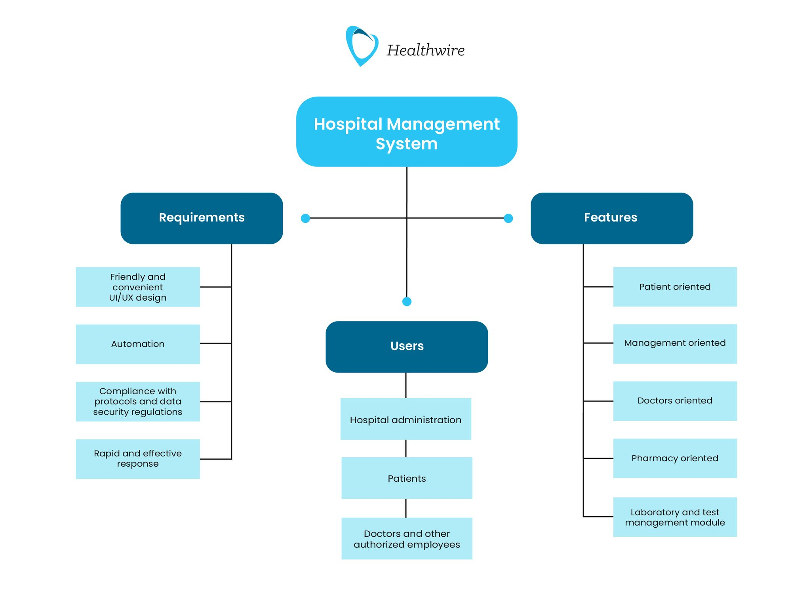

User stories:

User

* 1. User should have login details for Helthwire.
  2. User should access the Hospital administration details.
  3. User should access the patients details like (no patients , disease ect).
  4. User should access doctors details(doctors availability, doctors specialisation ect).
  5. User should access employees details.

Sprint Backlog:

The Sprint Backlog is a plan by and for the Developers. It is a highly visible, real-time picture of the work that the Developers plan to accomplish during the Sprint in order to achieve the Sprint Goal. Consequently, the Sprint Backlog is updated throughout the Sprint as more is learned. It should have enough detail that they can inspect their progress in the Daily Scrum.

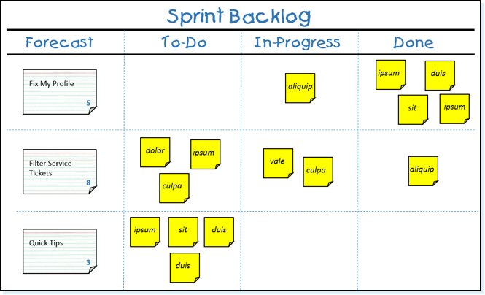

Sprint:

Sprint is a actual time spent by develop one or more stories.

Product Owner:(decision maker)

product owner is a person who is responsible for delivery of the software to the customer in the planned period of time.

They have a deep understanding of the customer's needs, market demands, and business goals. Based on this understanding, they make decisions about what features and functionalities should be included in the product.

Product backlog:

. The Product Owner maintains the product backlog, which is a prioritized list of all features, enhancements, and fixes that need to be implemented.

They are responsible for ensuring that the backlog is continuously refined, updated, and prioritized based on feedback, changes in market conditions, and other factors.

Scrum master:

Scrum Master is a key role responsible for facilitating the Agile process and ensuring that the Scrum team follows Scrum practices effectively.

Increment:

an increment refers to the sum of all the work completed during a sprint, or iteration, which meets the team's definition of done. It is a tangible outcome of the sprint and represents a potentially shippable product increment.

Daily scrum:

 Daily scrum is a 15 minute daily meeting used by the development team to integrate activities and to create a plan for the next 24 hours of development.

Sprint retrospective :

This meeting is held after the sprint review meeting. In this meeting, all the team members including the Scrum Master and Manager discuss the following topics:

*1. The key takeaways from the sprint.*

*2. What things went well and what things didn’t ?*

*3. What problems were faced during the sprint ?*

*4. What other possible decisions could’ve been taken at that point.*

*5. Analysing the merits and demerits faced during the sprint.*

b. Link for Agile Workflow :

<https://www.atlassian.com/agile/project-management/workflow>

c. Agile presentation attached

d. Agile retrospective :

<https://www.aha.io/roadmapping/guide/agile/what-is-an-agile-retrospective>

e. Agile By Example [video] :

<https://www.youtube.com/watch?v=o_4z-dfA6PY>

[Manifesto for Agile Software Development (agilemanifesto.org)](https://agilemanifesto.org/)